Scalable Blog Hosting Platform Using AWS VPC,EC2,S3 and RDS

_ASHOK.S

CONTENTS ;
- Introduction
- Create Vpc
- Create Networking
- Set Up the Web Tier
- Create s3
- Set Up the Database Tier
- Install and Configure wordpress using apache2 server
- Output

INTRODUCTION

Architecture is a client-server model where the application is divided into two main layers: the Client Tier and the Database Tier. In this setup, client computers directly communicate with the database server to request and manage data. The client tier handles the user interface and application logic, while the database tier stores and manages the data.s3 tire used to backup client files, This architecture is simple, cost-effective, and suitable for small to medium-sized applications. It provides faster communication since there is no intermediate layer between the client and the database. However, it may face scalability and security challenges as the number of users increases.

Set Up Networking:
VPC Settings:
VPC only
Name: wordpress
IPv4 CIDR block: IPv4 CIDR manual input
IPv4 CIDR: 10.0.0.0/16
IPv6 CIDR block: No IPv6 CIDR block
Click “Create VPC”
Next create the Internet Gateway
Select “Internet Gateway” from the VPC dashboard
Name: my-wordpress-igw

Click “Create Internet Gateway”
Attach the Internet Gateway to my VPC

Subnet Creation:
Now I will create 2 public subnets and 2 private subnets 2db subnet using two different zones
Select “Subnets” from the VPC dashboard
Click create subnet
Select my VPC for the subnets
Subnet Name: my-subnetpublic1
AZ: us-east-1a
IPv4 subnet CIDR block: 10.0.1.0/24

Add Subnet
Subnet Name: my-subnetpublic2
AZ: : us-east-1b
IPv4 subnet CIDR block: 10.0.2.0/24

Add subnet
Subnet Name: : my-subnetprivate1
AZ : us-east-1a
IPv4 subnet CIDR block: 10.0.3.0/24
Add subnet
Subnet Name: my-subnetpivate2
AZ: us-east-1a
IPv4 subnet CIDR block: 10.0.4.0/24
Add db subnet
Subnet name; mydbsubnet1
AZ; us-east-1a
IPv4 subnet CIDR block: 10.0.4.0/28
Add db subnet
Subnet name;mydbsubnet2
AZ; us-east-1b
IPv4 subnet CIDR block: 10.0.16.0/28

Click “Create Subnet”
Select Route tables in the VPC dashboard
Create 2 Route Table for both public and private subnet
1)
Name:My Public RT
VPC: wordpress
Click “Create route table”
2)
Name:My Private RT
VPC: wordpress
Click “Create route table”
The Public Route Table needs to be associated with my public subnets for this go to Subnets associations tab after selecting the Route Table and then click Edit subnet associations
Select the 2 public subnets and click save associations
Next the Private Route Table needs to be associated with my private subnets for this go to Subnets associations tab after selecting the Route Table and then click Edit subnet associations
Select the 2 private subnets and 2db click save associations

Now we ensure that our created Route Tables are routed to Internet Gateway.
For this select the public route table and click edit routes
Then I selected my Internet Gateway and saved traffic to be routed.
Move to Your VPC to select the created VPC and check the resource map for the right connection.

Set Up the Web Tier:
Go to “EC2” in the console and click launch an instance
Name: wordpress
AMI: Ubuntu
Instance type: t3micro
Key pair: ashokaura.pem
Edit the network settings
VPC: wordpress
Subnet: PublicSubnet-1
Auto-assign public IP: Enable
Click “Launch instance”
Ensure that SSH, HTTP, HTTPS and mysql & aurora are allowed in the default security group.

Set Up the Database Tier:
Go to RDS in the console and select subnet group in dashboard
Name: AWS Subnet Group
Description: Subnet Group
VPC: wordpress
AZ: us-east-1a
Subnet: Privatesubnet-1, Privatesubnet-2
Click “Create subnet group”
Select Database in dashboard and click create Database

Choose a database creation method: Full configuration
Engine options: MySQL
Templates: Sandbox Template
DB instance identifier: wordpress-database
Master username: admin
Credentials management: Self-managed
Master password: admin12345
Confirm master password: admin12345

Compute resource: Connect to an EC2 compute resource
EC2 instance: wordpress

DB subnet Group: AWS Subnet Group (we created)
Public Access: yes
VPC security Group: Choose existing- default
Click “Create database”
Create s3 bucket
Bucket Name ; aura-wordpress
Disable block all public access
Click create bucket

Install and Configure
Connect to the EC2 instance to install by following these commands.
1.sudo apt update
2.sudo apt upgrade -y
3.sudo apt install apache2 -y
4.sudo apt install -y apache2 php php-mysql php-xml php-mbstring php-intl unzip wget libapache2-mod-php
5.sudo systemctl restart apache2
visit ip address for apache is correctly installed
6.sudo apt-get update
7.sudo apt-get install mysql-client -y
replace our current endpoint code and user name we created (8)
8.mysql -h wordpress-database.cihgmom0kn70.us-east-1.rds.amazonaws.com -u admin -p
9.enter password what we use (PWD no transperent hit hidden language so enter correctly and enter)
10.CREATE DATABASE wordpress;
11.EXIT;
configure wordpress
12.cd /var/www/html
13.sudo wget https://wordpress.org/latest.tar.gz
14.sudo tar -xzvf latest.tar.gz
15.sudo mv wordpress/* .
16.sudo rm -rf wordpress latest.tar.gz index.html
17..sudo chown -R www-data:www-data /var/www/html
ls -l
18.sudo mv wp-config-sample.php wp-config.php
19.sudo nano wp-config.php\

After install copy the publicip paste in new terminal
CONFIGURATION
Site Name: wordpress
Email: Awsashok28@gmail.com
Username: admin
Password: admin12345
Confirm Password: admin12345
Click Next
DATABASE
Database Type: MySQL
Host Name: wordpress-database.cihgmom0kn70.us-east-1.rds.amazonaws.com
Username: admin
Password: admin12345
Database Name: wordpress-database
Table Prefix: Default
Old Database Process: remove

Snap of wordpress ec2 connect

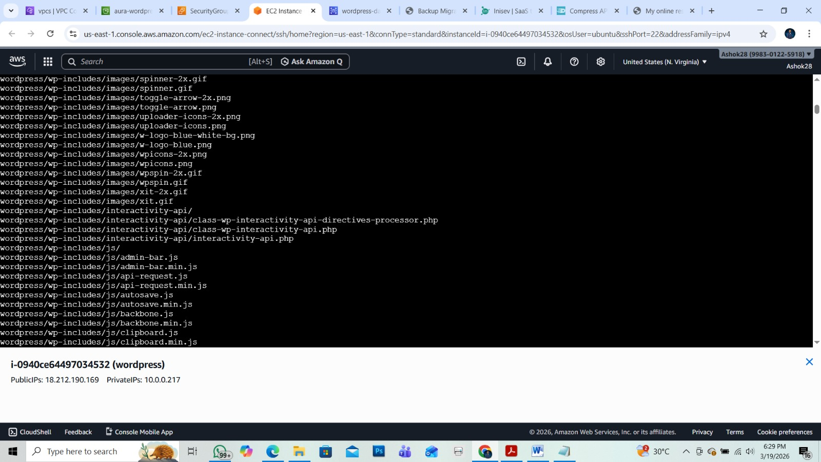

Wordpress install snap
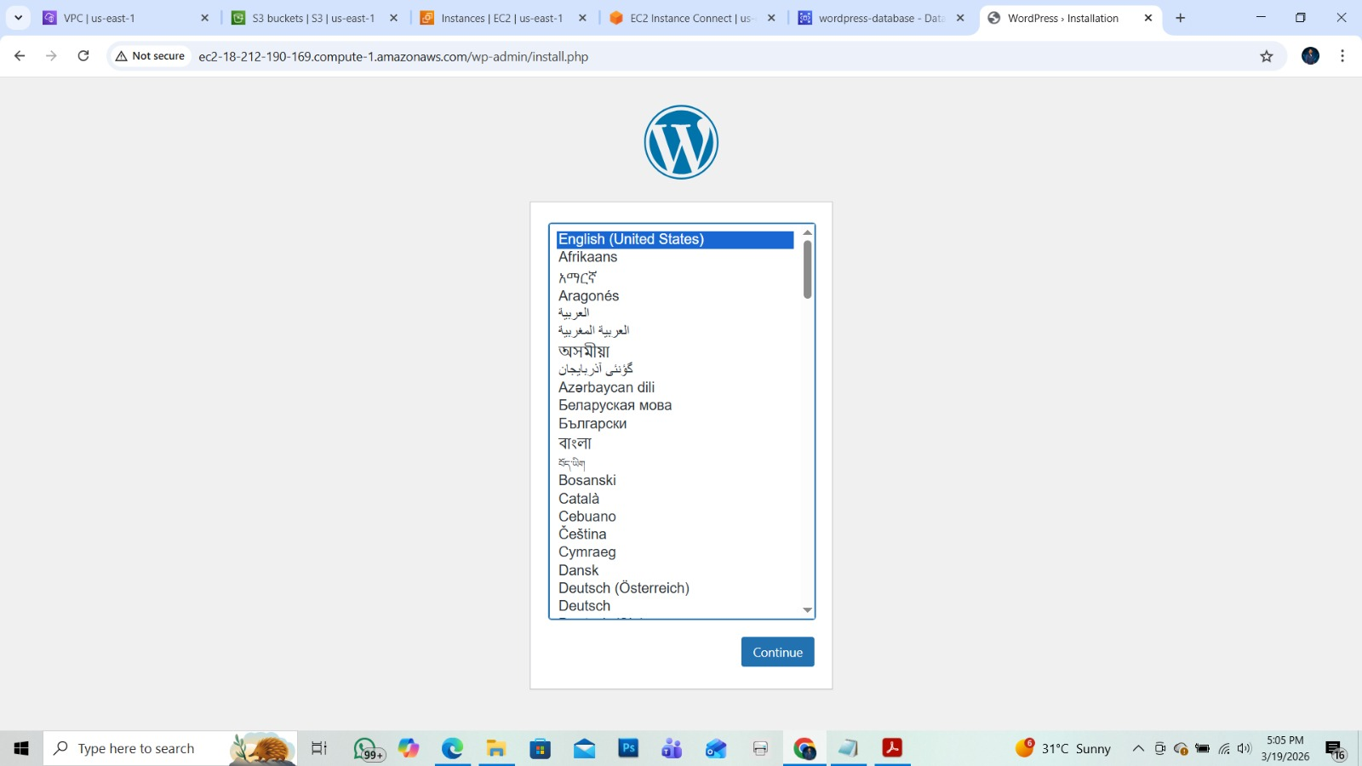

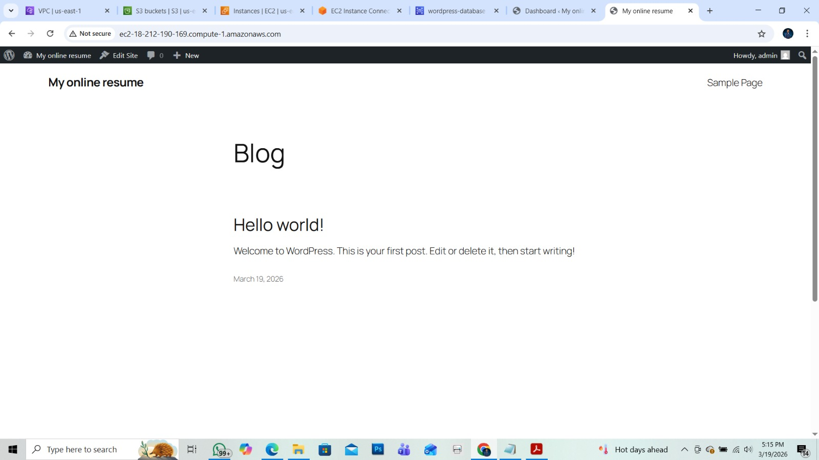

Login page
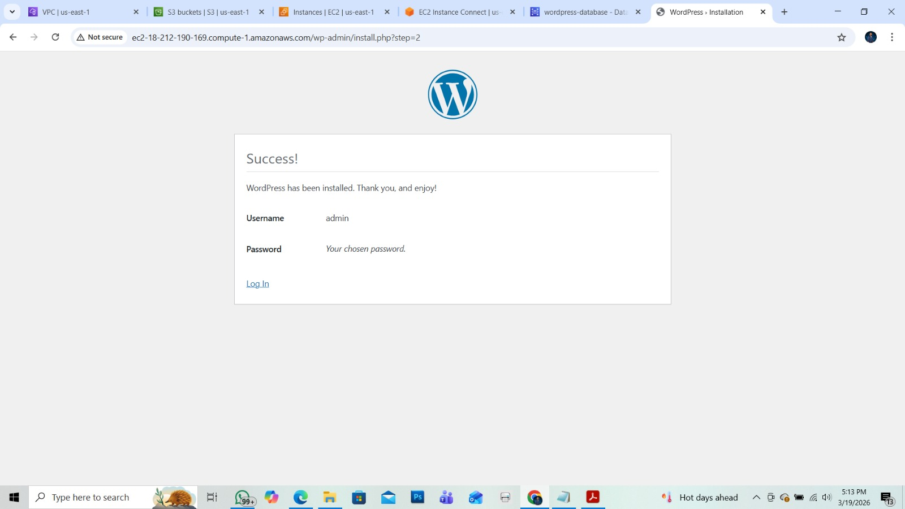

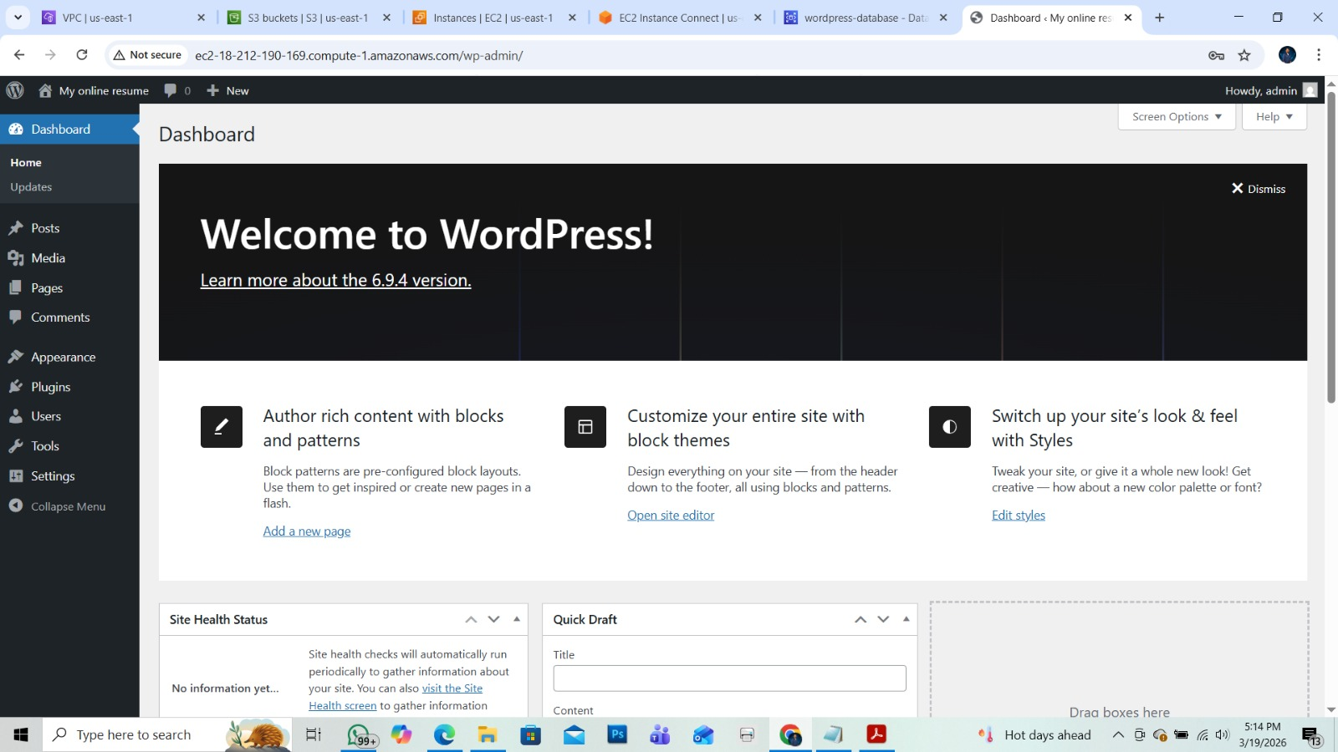

Admin page
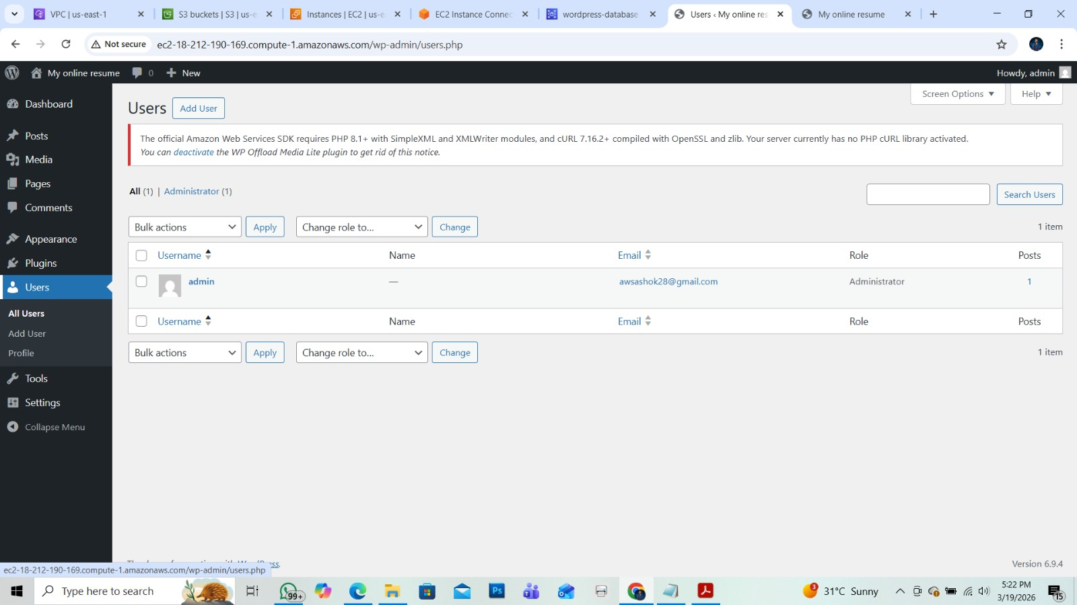

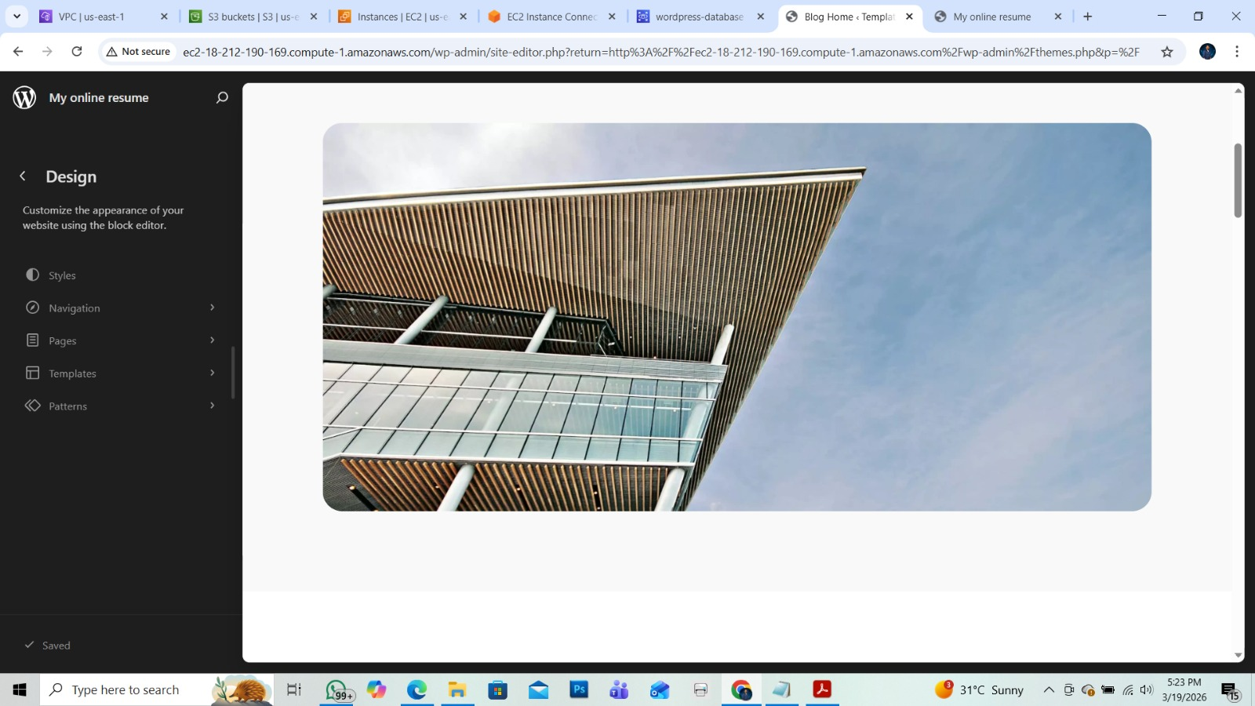

Data base
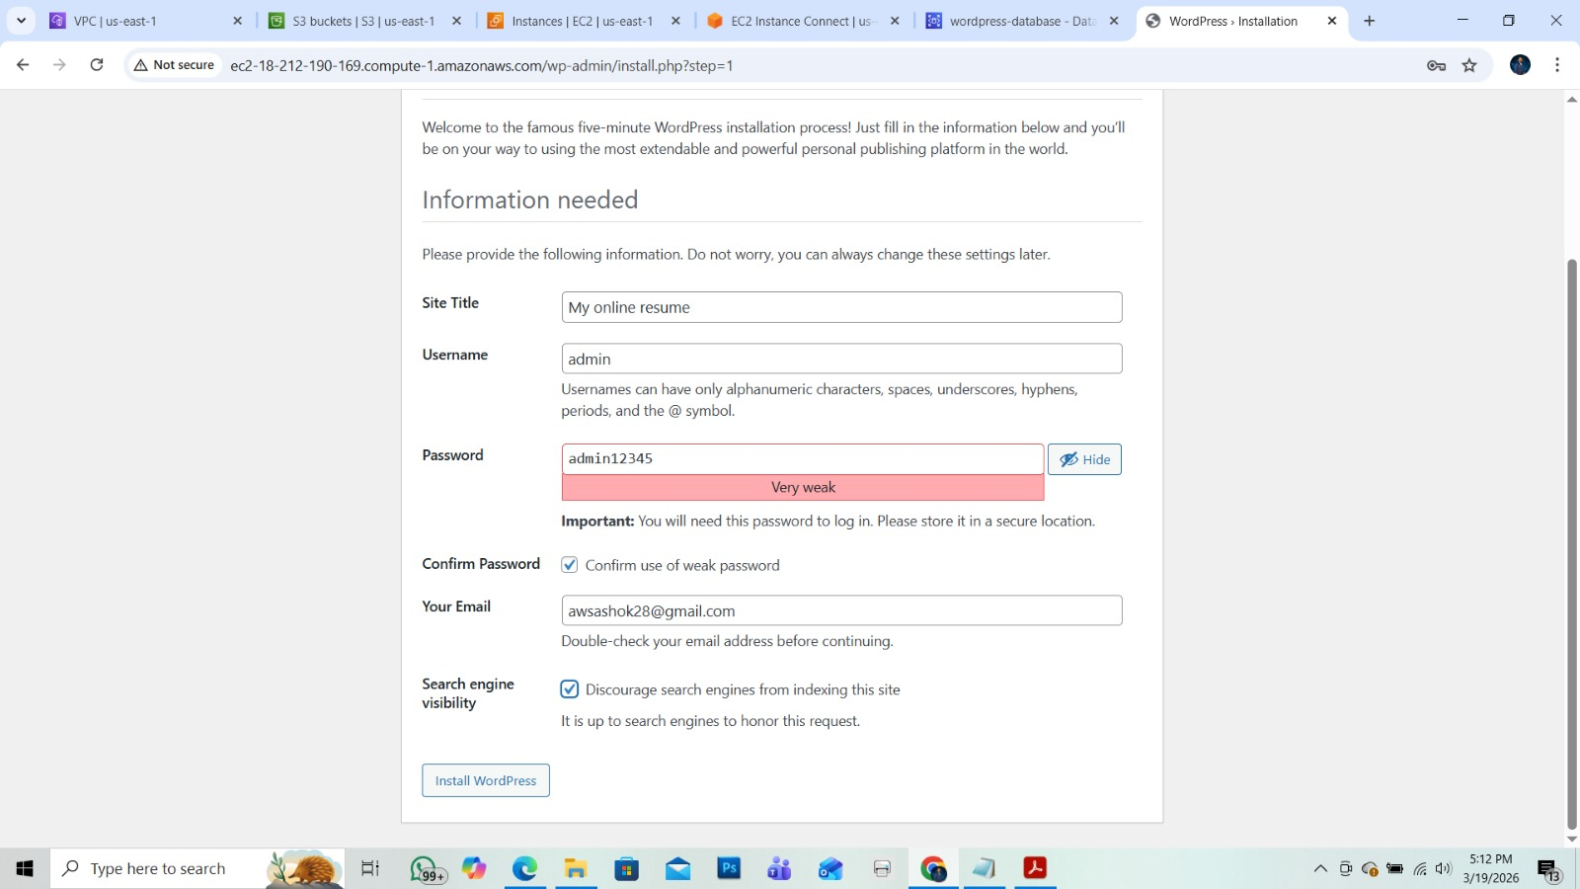
S3
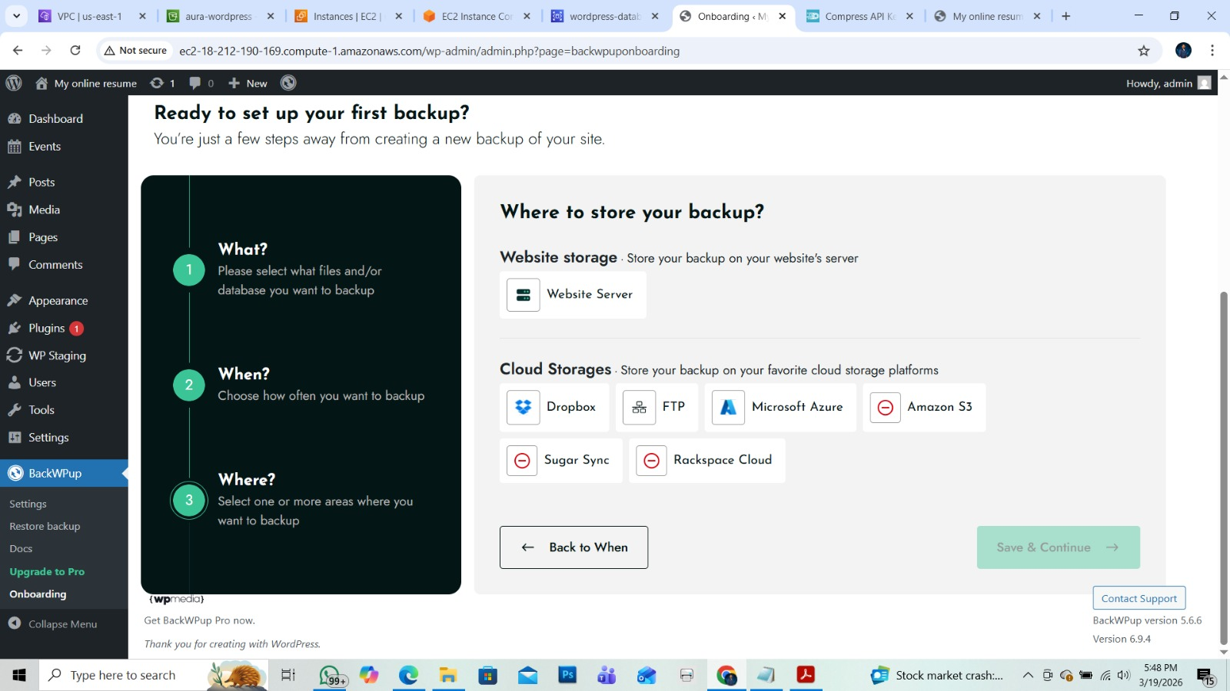Not able to show s3 setup because that option only need to upgrade that show in snap for point of view.s3 bucket is used to setup client databackup..

Thankyou

